*Social media post*

1. Introduction:

* 1. OVER VIEW :

* I Design a social media poster using canva.it is best to think of a poster as a trending that you can use to any social media platform.canvas is very easy way to use any templates regarding social media post and any can use it without any obstacles.

1.2 purposes:

* My project is create a social media poster .i create a face book post using in this canvas. Social media posts are an important part of any social media marketing strategy. They allow businesses to build a community around their brand and establish a meaningful presence in the online space

2. Problems definition & design thinking

2.1 Empathy map:

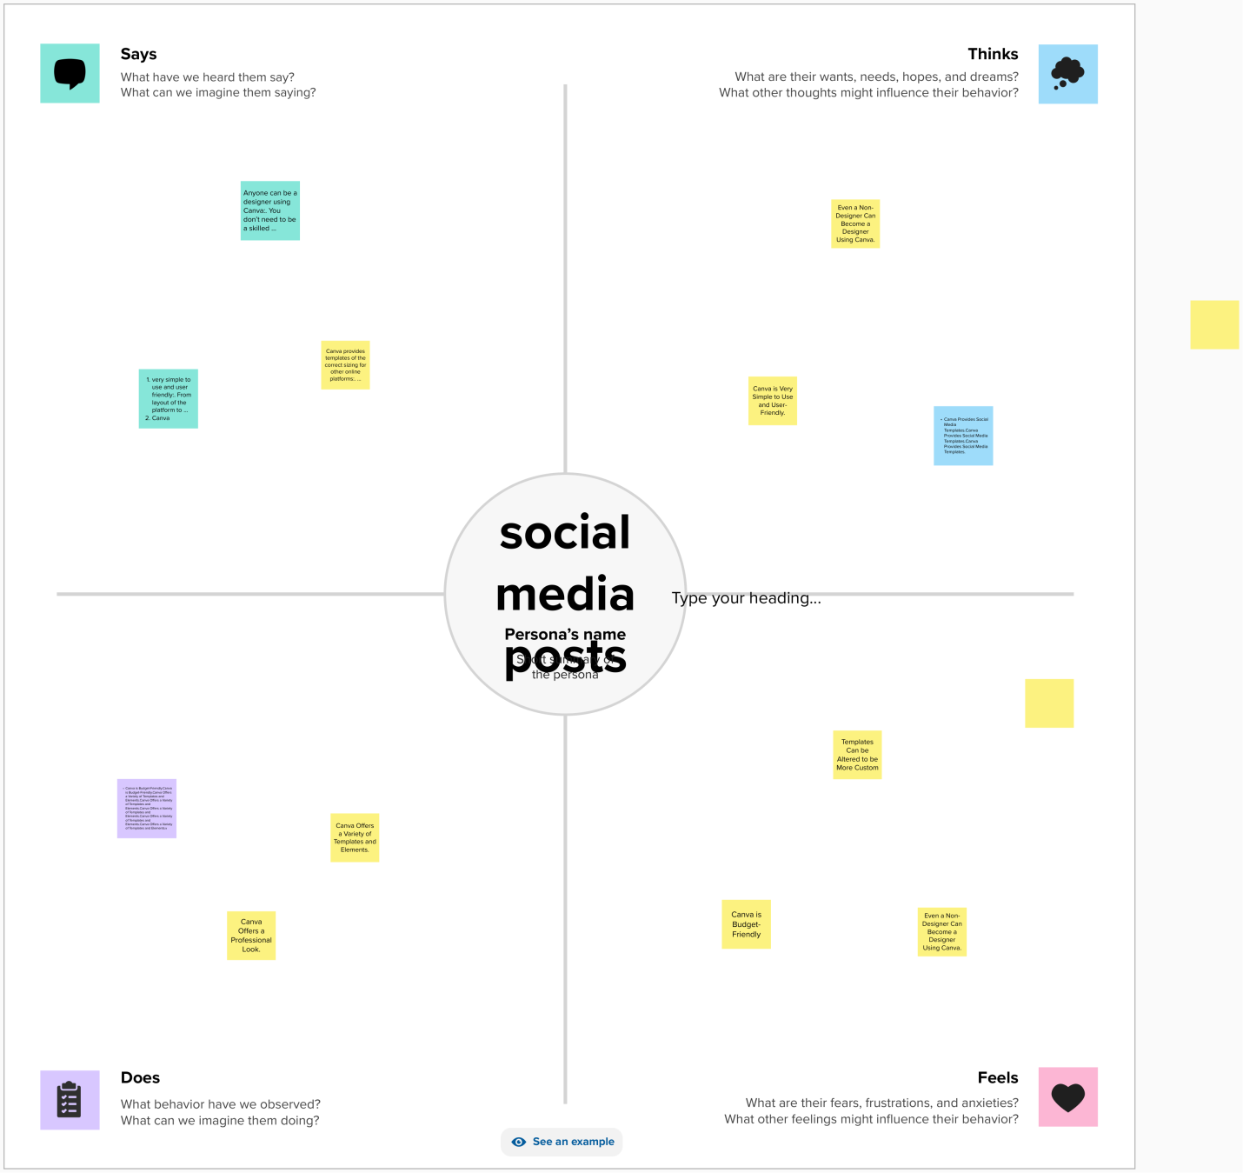

2.2 brain storm and idea prioritization

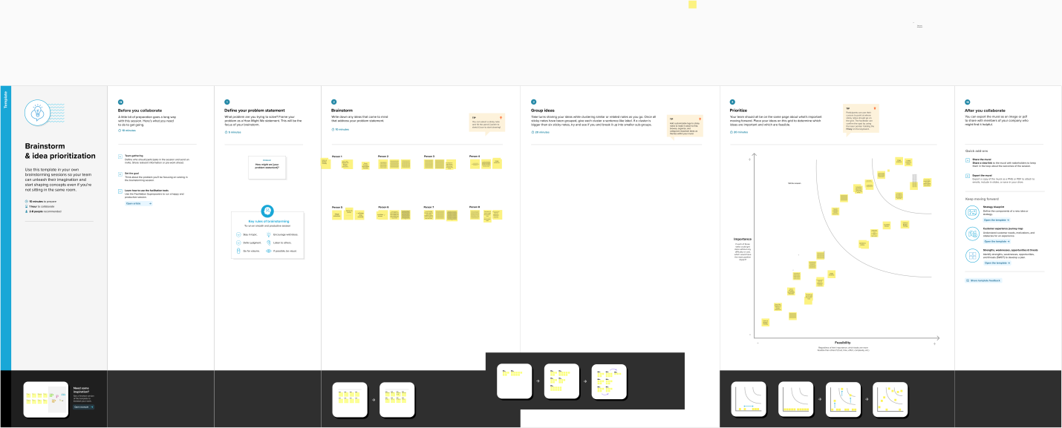

**RESULT**



**4. Advantages**:

* Easy to using this canvas
* Fresher’s easy to design anything in this canvas
* In this canvas has many templates
* Canvas was very useful to everyone

**5. Conclusion**:

* We easily finish my project visually appealing certificate for a debate .canvas is the most useful and best app for the fresher’s .because that she has many templates that was easy to use.